This article delves into a Python codebase dedicated to a meal information application. The app employs the Tkinter library to create a graphical user interface (GUI) and utilizes the themed API to retrieve meal-related data. The app allows users to enter a meal name in a text input field and retrieve detailed information about the meal, including instructions on preparing it.

The codebase is well-organized, modular, and easy to follow, making it an excellent example for anyone looking to learn how to build GUI applications in Python or how to use the themealdb API. In this article, we will provide a detailed explanation of the code, highlighting its various components and how they work together to create a functional meal information app.The codebase consists of a single Python file that defines a class called StyledMealApp. The class's constructor takes a single argument, master, which is the application's main window. The constructor sets various attributes of the main window, such as its title, geometry (size), background color, and custom style. It also creates a frame for the input field and button and another frame for displaying the meal information.

The StyledMealApp class has several methods that implement the application's functionality. The get_styled_meal_info method is called when the user clicks the "Get Meal Info" button. It retrieves the user-entered meal name, encodes it, and constructs the API URL. It then calls the get_data_from_api method to retrieve the meal data from the API.

The get_data_from_api function uses the requests library to perform an HTTP GET request to the API, and subsequently, it furnishes the JSON response as its result. The display_styled_meal_info method takes the meal data as an argument and displays the meal name and instructions in the result label. An appropriate message is displayed if the meal is not found or an error occurs.

The if *_name_* == "*_main_*": block at the end of the code creates the main window, an instance of the StyledMealApp class, and starts the main event loop with root.mainloop().

The code imports several libraries at the beginning of the file. The requests library makes HTTP requests to the API, while tkinter and ttk are used to create the GUI. The urllib.parse library encodes the user-entered meal name for use in the API request.

Creating the Main Window

The StyledMealApp class's constructor creates the main window of the application. It sets the window's title, geometry, background color, and custom style. The custom style is set to "clam," a built-in style in tkinter.The StyledMealApp class creates a frame for the input field and button using the ttk.Frame widget. The frame is created with a padding of (20 and 10) to provide some space around the widgets. The frame is then added to the main window using the grid method. The StyledMealApp class creates labels and input fields for users to enter the meal name. The labels are created using the ttk.Label widget, and the input fields are created using the ttk.Entry widget. The labels and input fields are added to the frame using the grid method. The StyledMealApp class creates a button for the user to click to retrieve meal information. The button is created using the ttk.Button widget and is connected to the get_styled_meal_info method using the command parameter. The button is added to the frame using the grid method. The StyledMealApp class creates a frame for displaying the meal information using the ttk.Frame widget. The frame is created with a padding of (20, 10) to provide some space around the widgets. The frame is then added to the main window using the grid method.

Creating a Label to Display Meal Information

The StyledMealApp class creates a label for displaying the meal information using the ttk.Label widget. The label is created with a wrapping length of 500 to allow long text to wrap to the following line. The label is also created with a justification of "left" to align the text to the left. The label is added to the frame using the grid method.The get_styled_meal_info method is called when the user clicks the "Get Meal Info" button. The method retrieves the user-entered meal name, encodes it, and constructs the API URL. It then calls the get_data_from_api method to retrieve the meal data from the API.

The get_data_from_api method initiates an HTTP GET request to the API by employing the requests library, and it retrieves and returns the JSON response. The get_styled_meal_info method then checks if the response contains meal data and displays it in the result label. An appropriate message is displayed if the meal is not found or an error occurs.The display_styled_meal_info method takes the meal data as an argument and displays the meal name and instructions in the result label. The method creates a string containing the meal name and instructions and sets the label's text to the string.The if *_name_* == "*_main_*": block at the end of the code creates the main window, creates an instance of the StyledMealApp class, and starts the main event loop with root.mainloop().

Conclusion

In this article, we explored a Python codebase for a meal information app that utilizes the tkinter library for the GUI and the themealdb API to fetch meal information. The codebase is well-organized, modular, and easy to follow, making it an excellent example for anyone looking to learn how to build GUI applications in Python or how to use the themealdb API.

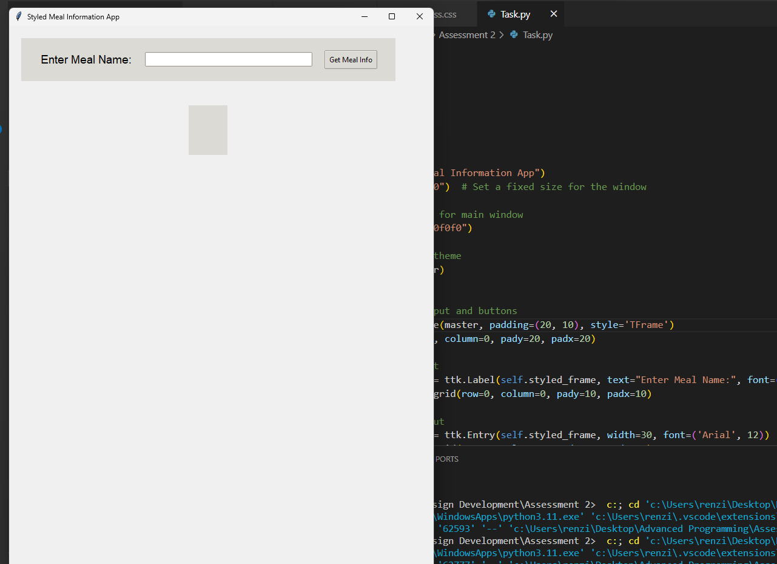

*(Evidence for Testing)*

The codebase consists of a single Python file that defines a class called StyledMealApp. The class's constructor creates the main window of the application, creates a frame for the input field and button, and another frame for displaying the meal information. The class also defines several methods that implement the application's functionality, such as getting meal information from the API and displaying it.